**安装点微（插件管理工具）**

**下载地址**：[http://download.tomwx.cn/tom_6.0.zip](http://download.tomwx.cn/tom_6.0.zip" \t "http://www.tomwx.cn/_blank)

**第一步：FTP上传程序文件到你论坛根目录  source/**

**（注意：这里是覆盖不是替换）**

[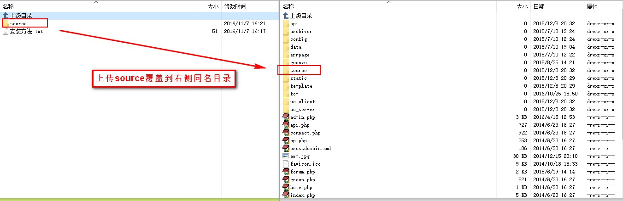](http://www.tomwx.cn/source/plugin/tom_editor/editor/attached/image/20161107/20161107171032_76172.jpg)

**第二步：进入论坛后台应用管理 》》 安装 》》 点微（插件管理工具）**

[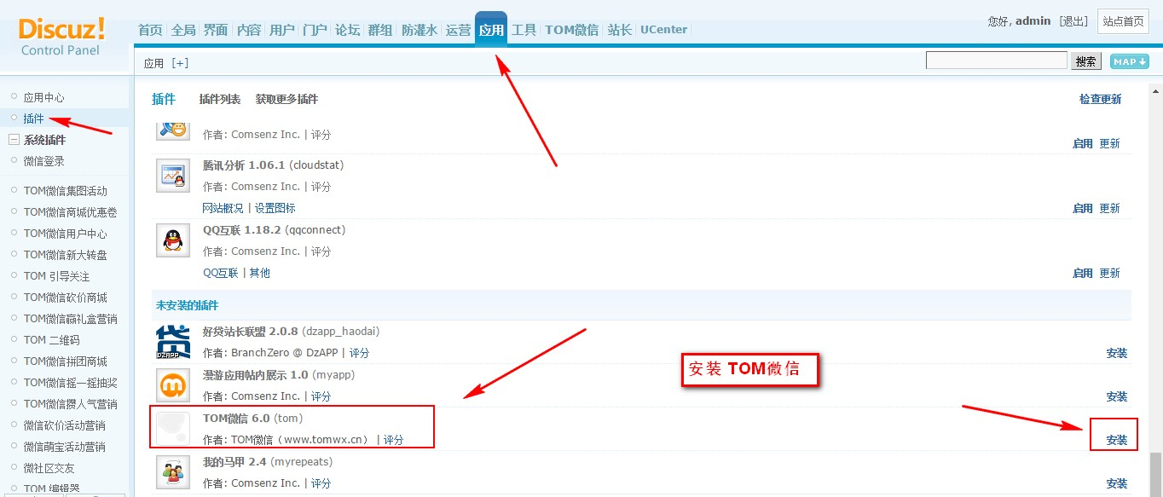](http://www.tomwx.cn/source/plugin/tom_editor/editor/attached/image/20161107/20161107171106_35369.jpg)

[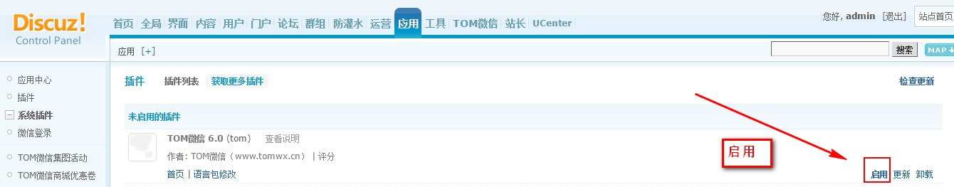](http://www.tomwx.cn/source/plugin/tom_editor/editor/attached/image/20161107/20161107171523_68996.jpg)

**第四步：退出论坛重新登录进入**

[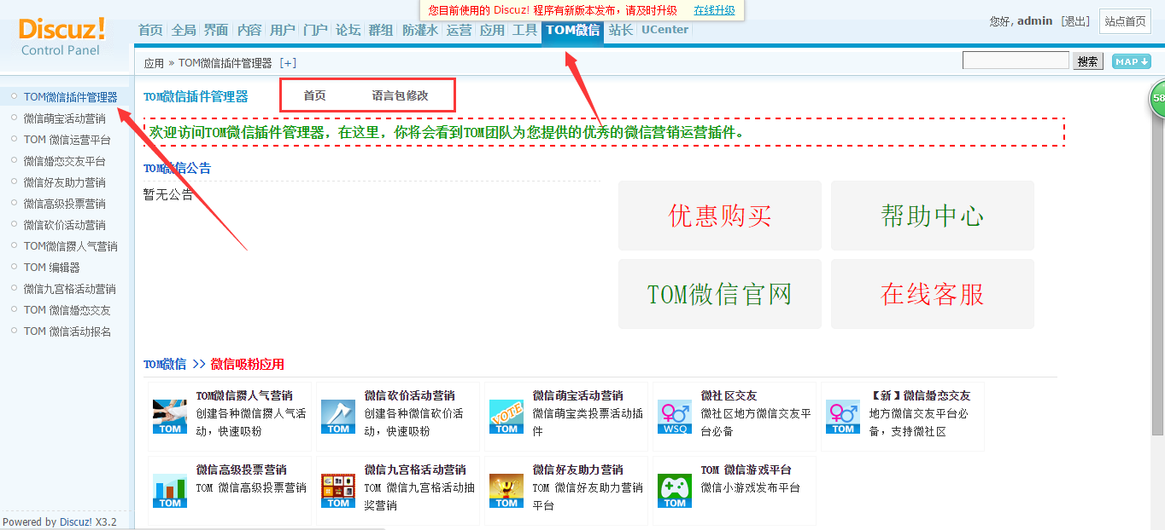](http://www.tomwx.cn/source/plugin/tom_editor/editor/attached/image/20150720/20150720180305_43766.png)

**第五步：如何备份数据库**

[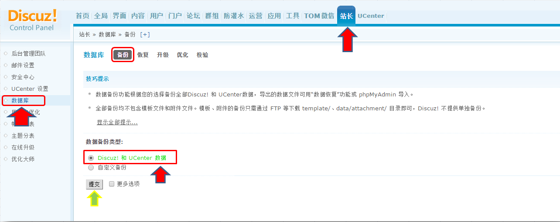](http://www.tomwx.cn/source/plugin/tom_editor/editor/attached/image/20151030/20151030093925_96986.png)

**第六步：语言包可以修改每个插件文字**

[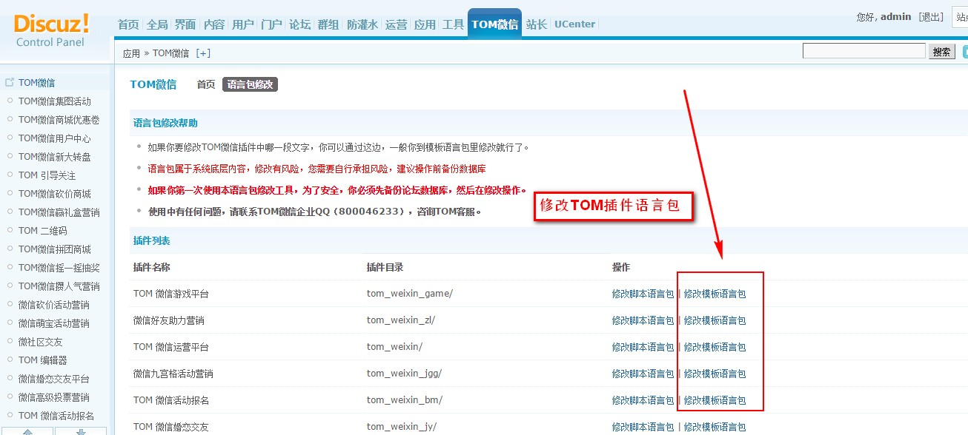](http://www.tomwx.cn/source/plugin/tom_editor/editor/attached/image/20161107/20161107171626_64427.jpg)